

A Project Report On

**ATM Interface**

**By**

**Akash.N**

**Batch:** 2022-7888

**Center: Bangalore tc palya**

Under the Guidance of,

**Chittaranjan Ghosh.**

**Technical Trainer**

**EduBridge**

(Digital Academy – Certification program in Java Full Stack)

## Introduction:

We can construct an ATM program in Java to display ATM transactions. An automated teller machine (ATM) or cash machine is an electronic telecommunications system that allows customers of banking firms to conduct financial transactions. The user must choose a choice from the options shown on the screen in the ATM application. For example, withdraw money, deposit money, check your balance, and exit the available options

. **Modules:-**

* **Withdraw:** For withdrawing the funds, gets the withdrawal amount from the user, deduct it from the total balance, and display the message.
* **Deposit:** For depositing the funds, gets the deposit amount from the user to add, add it to the total balance, and display the message.
* **Check the balance:**For checking the balance, display the user’s total balance.
* **Exit:** Return the user to the home page or initial screen by exiting the current Transaction mode
* As in the above program, the ATM class is created which contains withdraw (), deposit() and print balance () functions. The withdraw () function is used to perform the withdraw operation; this function accepts the balance and the withdrawn amount. Inside the withdraw () function, first check whether the balance is greater than the withdraw amount or not; when it is true, then update the balance by subtracting the withdraw amount from the balance. Next, the function deposit () is used to performs the deposit operation; this function accepts the balance and the deposit amount.
* Inside the deposit () function, it updates the balance by adding the deposit amount to the balance. Next, the print balance () function is used to print the balance; it accepts the balance. Then, in the main function, a balance variable of an integer is created. Next, printing the selecting pitons for withdrawing, deposit, balance, and exit operations, depending on the specific option selection the case gets to execute, as we can see in the above output

**Software Requirements:**

**Back end**: MySQL Workbench 8.0 C E, Java 8.0

**Browser:**  Google Chrome

**Operating System:** Window

# MySQL:

# : create database atm_db

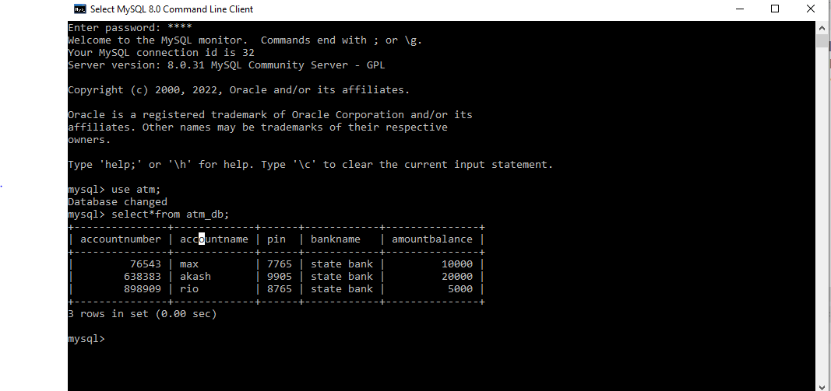

# Module Test Cases:

### 1. Balance Check Module -

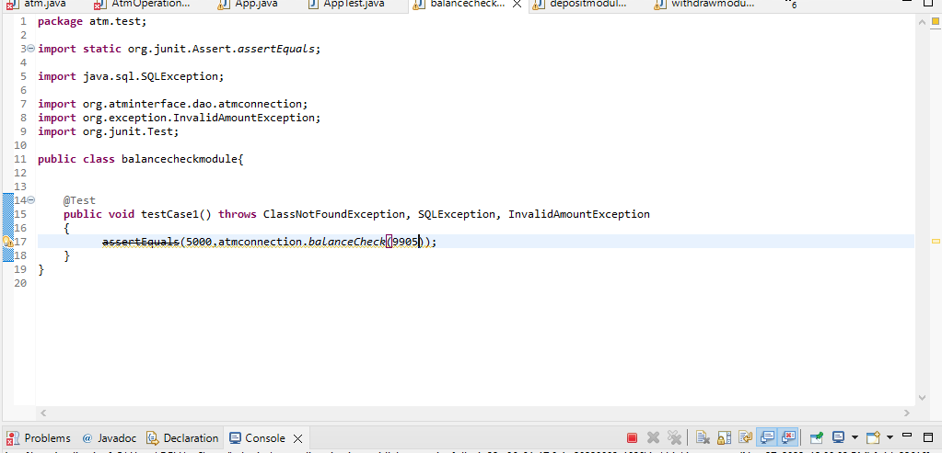

### **2.Withdraw Module –**

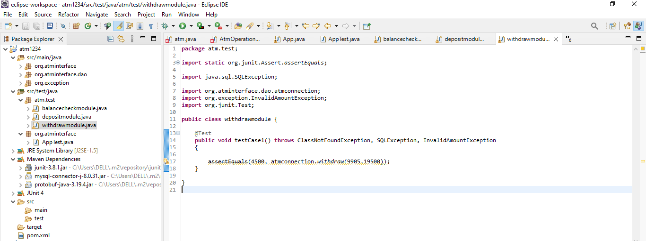

### **3 .Deposit Module** -

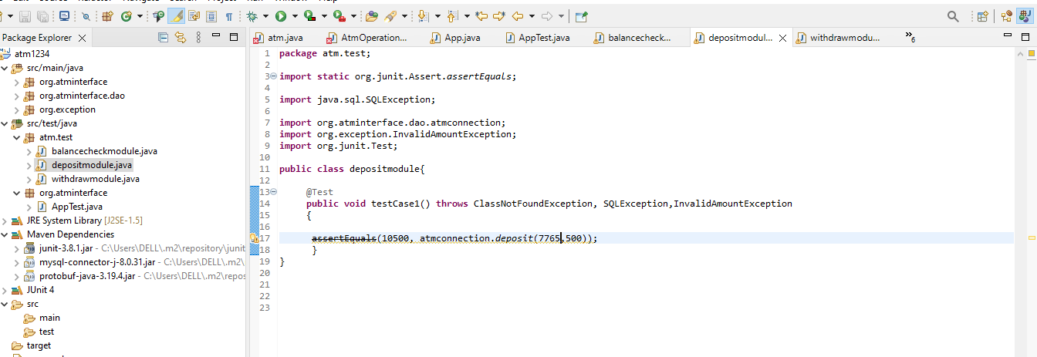

# CONSOLE OUTPUT:

## Entering ATM:

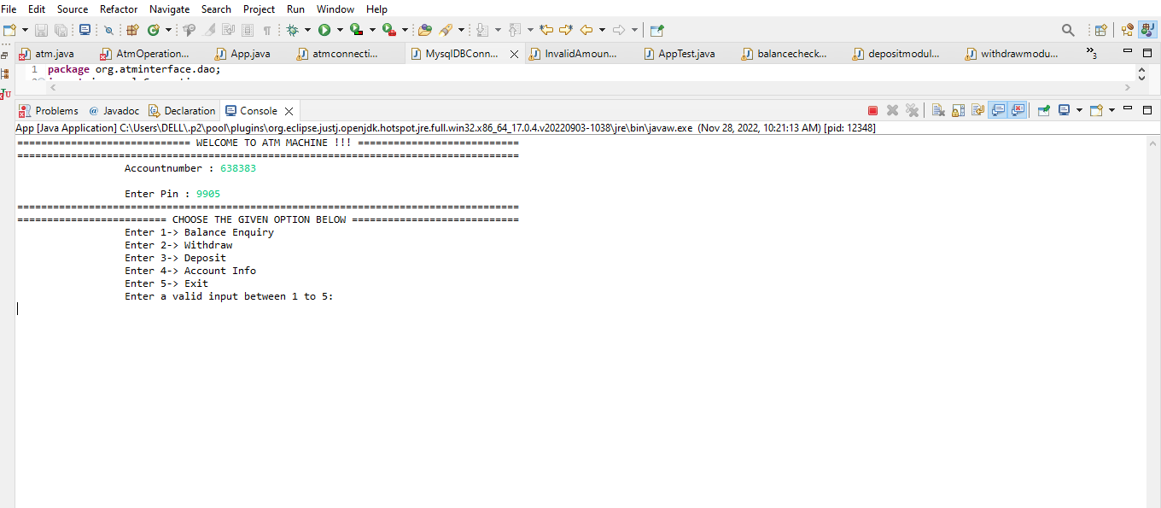

## Balance Enquiry:

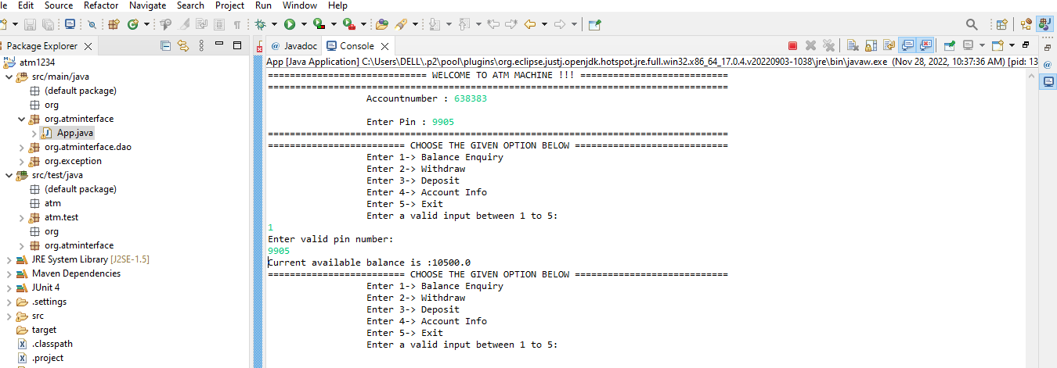

## Withdraw amount

## C:\Users\DELL\Pictures\Screenshots\output00.PNG

## Deposit Amount:

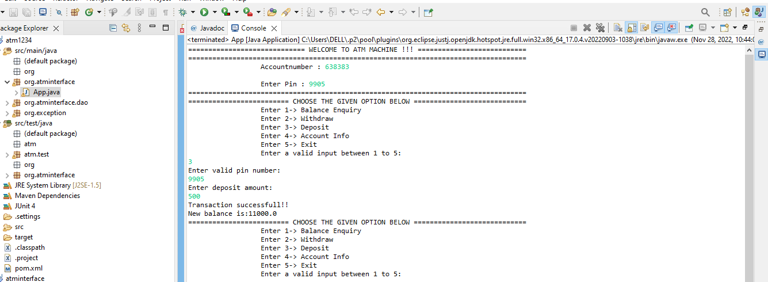

## Check Account:

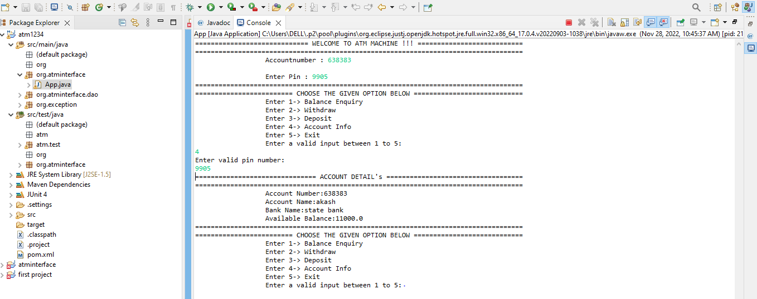

# Exit:

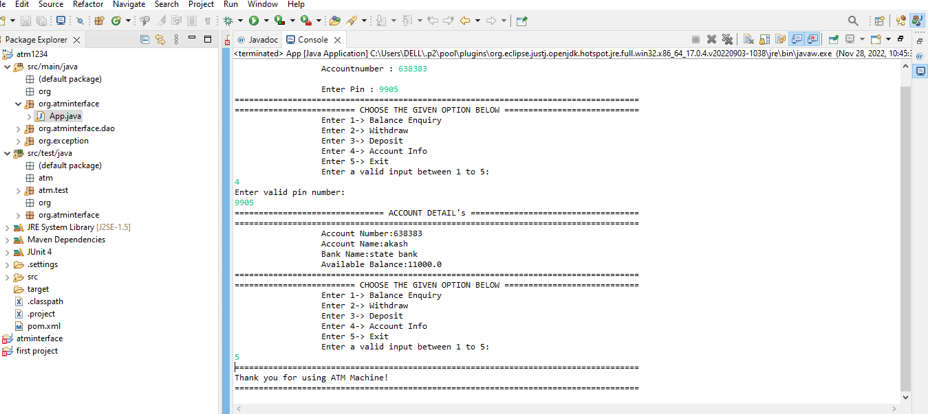

# CONCLUSION:

ATM program in Java to display ATM transactions, and the user can withdraw money, deposit money, check balance, and exit from the ATM